1/25
- Proud
- Amused
- Enthusiastic
- Surprised

2/25
- Disapproval
- Appalled
- Dismissive
- Shy

3/25
- Irritated
- Shy
- Fearful
- Devastated

4/25
- Remorse
- Disappointed
- Skeptical
- Concerned

5/25
- Content
- Eager
- Thoughtful
- Astonished

6/25
- Uncaring
- Skeptical
- Deciding
- Discouraged

7/25
- Intrigued
- Excited
- Convinced
- Moved

8/25
- Skeptical
- Distracted
- Ashamed
- Confused

9/25
- Interested
- Pessimistic
- Nervous
- Deciding

10/25
- Uncaring
- Disapproval
- Appalled
- Regret

11/25
- Shame
- Rage
- Disbelief
- Remorse

12/25
- Contemplative
- Shock
- Uneasy
- Bored

13/25
- Calm
- Surprised
- Relieved
- Delighted

14/25
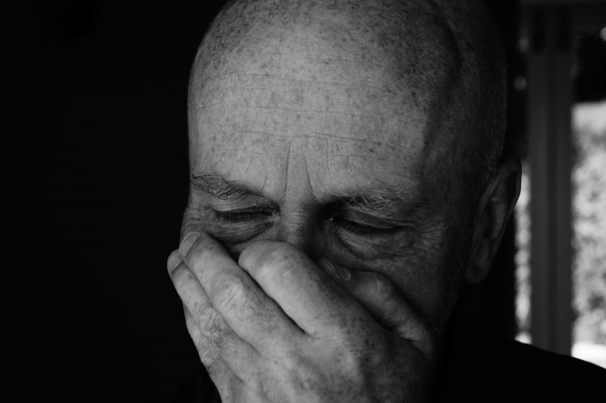
- Outrage
- Frantic
- Devastated
- Fearful

15/25
- Distracted
- Unimpressed
- Disgust
- Distressed

16/25
- Disappointed
- Shy
- Afraid
- Dismissive

17/25
- Distressed
- Frustrated
- Incredulity
- Moved

18/25
- Thoughtful
- Interested
- Pleased
- Curious

19/25
- Unimpressed
- Pensive
- Baffled
- Anger

20/25
- Questioning
- Impatient
- Alarmed
- Nervous

21/25
- Indifferent
- Contemplative
- Distracted
- Relaxed

22/25
- Skeptical
- Alarmed
- Devastated
- Arrogant

23/25
- Nostalgic
- Eager
- Mischievous
- Content

24/25
- Distraught
- Preoccupied
- Regret
- Unsure

25/25
- Disgust
- Distracted
- Concerned
- Wronged

